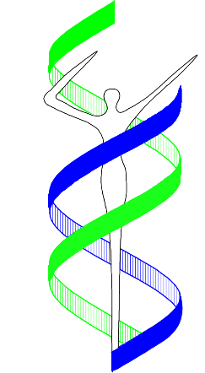MGC PhD Course

**Technology Facilities**

**Genomics and Transcriptomics**

March 6, 2025

Lecture room J1-117, LUMC Building 1

**Organizers:**

**Dr. Linda Broer, Erasmus MC, Rotterdam**

**Dr. Susan Kloet, LUMC, Leiden**

09:00 - 09:30 **Robert Kraaij**: Introduction to short read NGS

09:30 - 10:00 **Susan Kloet**: PacBio single molecule sequencing

10:00 - 10:40 **Yavuz Ariyurek**: 10X Genomics: single cell RNA-seq

10:40 - 11:00 coffee/tea break

11:00 - 11:30 **Costanza Vallerga**: Methylation: arrays and MeD-seq

11:30 - 12:00 **Natalia Escobar Salazar**: Spatial transcriptomics

12:00 - 13:00 lunch

13:00 - 13:30 **Robert Kraaij**: Oxford Nanopore sequencing

13:30 - 14:00 **Linda Broer**: Genotyping arrays

14:00 - 14:20 coffee/tea break

14:20 - 14:50 **Robert Kraaij** – Microbiome: 16S and metagenomics

14:50 - 15:20 **Susan Kloet**: LGTC and associated LUMC facilities

15:20 - 15:50 **Joyce van Meurs**: Genomics CoFa